NAME : Ashutosh Rode ROLL NO : 72 DIV : B

Q1] Create an android application to demonstrate the working of implicit intent. Use uri parsing.

Activity_main.xml:

<?xml version="1.0" encoding="utf-8"?>

<LinearLayout xmlns:android="[http://schemas.android.com/apk/res/android"](http://schemas.android.com/apk/res/android) xmlns:app="<http://schemas.android.com/apk/res-auto>" xmlns:tools="<http://schemas.android.com/tools>" android:layout_width="match_parent" android:layout_height="match_parent"

tools:context=".MainActivity" android:orientation="vertical">

<TextView android:layout_width="match_parent" android:layout_height="wrap_content" android:text="Implicit Intent" android:textSize="30dp" android:textAlignment="center" android:paddingBottom="10dp"/>

<EditText android:id="@+id/ed1"

android:layout_width="match_parent" android:layout_height="wrap_content" android:hint="Enter the url" android:textSize="20dp"/>

<Button

android:id="@+id/btn1" android:layout_width="wrap_content" android:layout_height="wrap_content" android:text="Submit" android:layout_gravity="center" android:layout_marginTop="150dp"/>

</LinearLayout> Mainactivity.java:

package com.example.implicitintent;

import androidx.appcompat.app.AppCompatActivity; import android.content.Intent;

import android.net.Uri; import android.os.Bundle; import android.view.View; import android.widget.Button;

import android.widget.EditText;

public class MainActivity extends AppCompatActivity { EditText ed1;

Button btn1;

NAME : Ashutosh Rode ROLL NO : 72 DIV : B

@Override

protected void onCreate(Bundle savedInstanceState) { super.onCreate(savedInstanceState); setContentView(R.layout.*activity_main*); ed1=findViewById(R.id.*ed1*); btn1=findViewById(R.id.*btn1*); btn1.setOnClickListener(new View.OnClickListener() {

@Override

public void onClick(View view) { String url=ed1.getText().toString();

Intent intent=new Intent(Intent.*ACTION_VIEW*,Uri.*parse*(url)); startActivity(intent);

}

});

}

}

Output:

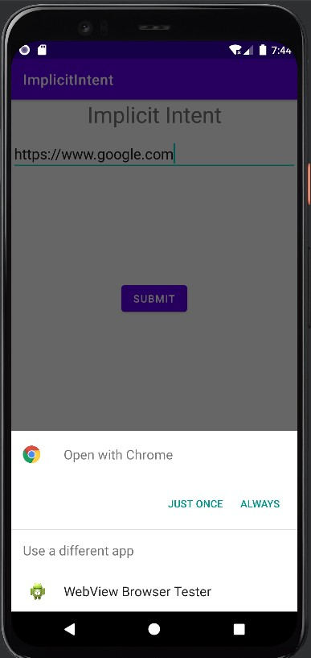

NAME : Ashutosh Rode ROLL NO : 72 DIV : B

Q2] Create an android application to demonstrate the working of implicit intent. Use Phone Calling.

Activity_main.xml:

<?xml version="1.0" encoding="utf-8"?>

<RelativeLayout xmlns:android="[http://schemas.android.com/apk/res/android"](http://schemas.android.com/apk/res/android) xmlns:app="<http://schemas.android.com/apk/res-auto>" xmlns:tools="<http://schemas.android.com/tools>" android:layout_width="match_parent" android:layout_height="match_parent"

tools:context=".MainActivity">

<EditText android:id="@+id/phoneNumberEditText" android:layout_width="match_parent" android:layout_height="wrap_content" android:hint="Enter Phone Number" android:layout_marginTop="32dp" android:layout_centerHorizontal="true" />

<Button

android:id="@+id/callButton" android:layout_width="wrap_content" android:layout_height="wrap_content" android:text="Make Phone Call" android:layout_below="@id/phoneNumberEditText" android:layout_centerHorizontal="true" android:layout_marginTop="16dp" />

</RelativeLayout> Mainactivity.java:

package com.example.callprogram;

import android.Manifest; import android.content.Intent;

import android.content.pm.PackageManager; import android.net.Uri;

import android.os.Bundle; import android.view.View; import android.widget.Button; import android.widget.EditText;

import androidx.annotation.NonNull;

import androidx.appcompat.app.AppCompatActivity; import androidx.core.app.ActivityCompat;

import androidx.core.content.ContextCompat;

NAME : Ashutosh Rode ROLL NO : 72 DIV : B

import com.example.callprogram.R;

public class MainActivity extends AppCompatActivity {

private static final int *REQUEST_CALL_PERMISSION* = 1; private EditText phoneNumberEditText;

private Button callButton;

@Override

protected void onCreate(Bundle savedInstanceState) { super.onCreate(savedInstanceState); setContentView(R.layout.*activity_main*);

phoneNumberEditText = findViewById(R.id.*phoneNumberEditText*); callButton = findViewById(R.id.*callButton*);

callButton.setOnClickListener(new View.OnClickListener() { @Override

public void onClick(View v) { makePhoneCall();

}

});

}

private void makePhoneCall() {

String phoneNumber = phoneNumberEditText.getText().toString();

if (!phoneNumber.isEmpty()) {

String dial = "tel:" + phoneNumber;

if (ContextCompat.*checkSelfPermission*(this, Manifest.permission.*CALL_PHONE*) != PackageManager.*PERMISSION_GRANTED*) {

ActivityCompat.*requestPermissions*(this, new String[]{Manifest.permission.*CALL_PHONE*}, *REQUEST_CALL_PERMISSION*);

} else {

Intent callIntent = new Intent(Intent.*ACTION_CALL*); callIntent.setData(Uri.*parse*(dial)); startActivity(callIntent);

}

}

}

}

Output:

NAME : Ashutosh Rode ROLL NO : 72 DIV : B

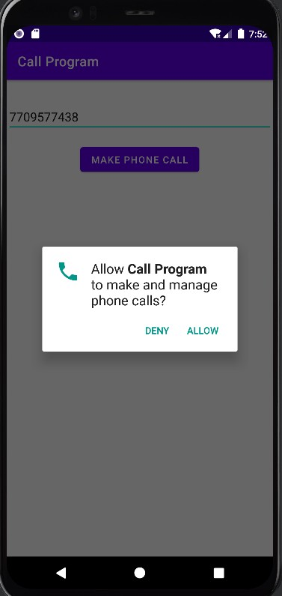

Q3] Create an android application to demonstrate the working of implicit intent. Use Email.: Activity_main.xml:

<?xml version="1.0" encoding="utf-8"?>

<RelativeLayout xmlns:android="[http://schemas.android.com/apk/res/android"](http://schemas.android.com/apk/res/android) xmlns:app="<http://schemas.android.com/apk/res-auto>" xmlns:tools="<http://schemas.android.com/tools>" android:layout_width="match_parent" android:layout_height="match_parent"

tools:context=".MainActivity">

<EditText android:id="@+id/recipientEditText" android:layout_width="match_parent" android:layout_height="wrap_content" android:hint="Recipient Email Address" android:layout_marginTop="32dp" android:layout_centerHorizontal="true" />

<EditText android:id="@+id/subjectEditText" android:layout_width="match_parent"

NAME : Ashutosh Rode ROLL NO : 72 DIV : B

android:layout_height="wrap_content" android:hint="Subject" android:layout_below="@+id/recipientEditText" android:layout_marginTop="16dp" android:layout_centerHorizontal="true" />

<EditText android:id="@+id/bodyEditText" android:layout_width="match_parent" android:layout_height="wrap_content" android:hint="Body"

android:layout_below="@+id/subjectEditText" android:layout_marginTop="16dp" android:layout_centerHorizontal="true" />

<Button

android:id="@+id/sendEmailButton" android:layout_width="wrap_content" android:layout_height="wrap_content" android:text="Send Email" android:layout_below="@id/bodyEditText" android:layout_centerHorizontal="true" android:layout_marginTop="16dp" />

</RelativeLayout> Mainactivity.java:

package com.example.emailprogram; import android.content.Intent;

import android.os.Bundle; import android.view.View; import android.widget.Button; import android.widget.EditText;

import androidx.appcompat.app.AppCompatActivity; public class MainActivity extends AppCompatActivity {

private EditText recipientEditText; private EditText subjectEditText; private EditText bodyEditText; private Button sendEmailButton; @Override

protected void onCreate(Bundle savedInstanceState) { super.onCreate(savedInstanceState); setContentView(R.layout.*activity_main*);

recipientEditText = findViewById(R.id.*recipientEditText*); subjectEditText = findViewById(R.id.*subjectEditText*); bodyEditText = findViewById(R.id.*bodyEditText*); sendEmailButton = findViewById(R.id.*sendEmailButton*); sendEmailButton.setOnClickListener(new View.OnClickListener() {

NAME : Ashutosh Rode ROLL NO : 72 DIV : B

@Override

public void onClick(View v) { sendEmail();

}

});

}

private void sendEmail() {

String recipientEmail = recipientEditText.getText().toString().trim(); String subject = subjectEditText.getText().toString();

String body = bodyEditText.getText().toString(); if (!recipientEmail.isEmpty()) {

Intent emailIntent = new Intent(Intent.*ACTION_SEND*); emailIntent.setType("text/plain"); emailIntent.putExtra(Intent.*EXTRA_EMAIL*, new String[]{recipientEmail}); emailIntent.putExtra(Intent.*EXTRA_SUBJECT*, subject); emailIntent.putExtra(Intent.*EXTRA_TEXT*, body);

}

}

}

Output:

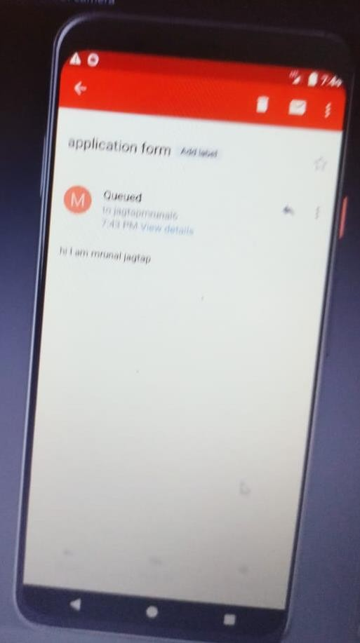

NAME : Ashutosh Rode ROLL NO : 72 DIV : B

Q4] Create an android application to demonstrate the working of explicit intent where insert user name and age from user and display both content on the second activity. Use putextra and getextra.

Activity_main.xml:

<?xml version="1.0" encoding="utf-8"?>

<RelativeLayout xmlns:android="[http://schemas.android.com/apk/res/android"](http://schemas.android.com/apk/res/android) xmlns:app="<http://schemas.android.com/apk/res-auto>" xmlns:tools="<http://schemas.android.com/tools>" android:layout_width="match_parent" android:layout_height="match_parent"

tools:context=".MainActivity">

<TextView android:id="@+id/txt1"

android:layout_width="match_parent" android:layout_height="wrap_content" android:text="User Data Form" android:textSize="30dp" android:textAlignment="center" android:paddingBottom="20dp”/>

<EditText android:id="@+id/ed1"

android:layout_width="match_parent" android:layout_height="wrap_content" android:layout_below="@+id/txt1" android:hint="Enter the name of User" android:paddingBottom="15dp"/>

<EditText android:id="@+id/ed2"

android:layout_width="match_parent" android:layout_height="wrap_content" android:layout_below="@+id/ed1" android:hint="Enter the age of User"/>

<Button

android:id="@+id/btn1" android:layout_width="wrap_content" android:layout_height="wrap_content" android:text="Submit" android:layout_below="@id/ed2" android:layout_centerHorizontal="true" android:layout_marginTop="100dp"/>

</RelativeLayout> Mainactivity.java:

package com.example.userdata;

import androidx.appcompat.app.AppCompatActivity;

NAME : Ashutosh Rode ROLL NO : 72 DIV : B

import android.content.Intent; import android.os.Bundle; import android.view.View; import android.widget.Button; import android.widget.EditText;

public class MainActivity extends AppCompatActivity { EditText ed1,ed2;

Button btn1; @Override

protected void onCreate(Bundle savedInstanceState) { super.onCreate(savedInstanceState); setContentView(R.layout.*activity_main*); ed1=findViewById(R.id.*ed1*); ed2=findViewById(R.id.*ed2*); btn1=findViewById(R.id.*btn1*); btn1.setOnClickListener(new View.OnClickListener() {

@Override

public void onClick(View view) { String name=ed1.getText().toString();

Integer age=Integer.*parseInt*(ed2.getText().toString());

Intent intent=new Intent(getApplicationContext(),MainActivity2.class); intent.putExtra("Name",name);

intent.putExtra("Age",age); startActivity(intent);

}

});

}

}

Activity_main2.xml:

<?xml version="1.0" encoding="utf-8"?>

<LinearLayout xmlns:android="[http://schemas.android.com/apk/res/android"](http://schemas.android.com/apk/res/android) xmlns:app="<http://schemas.android.com/apk/res-auto>" xmlns:tools="<http://schemas.android.com/tools>" android:layout_width="match_parent" android:layout_height="match_parent"

tools:context=".MainActivity2">

<TextView android:paddingTop="20dp" android:layout_marginTop="50dp" android:id="@+id/txt1"

android:layout_width="wrap_content" android:layout_height="wrap_content" android:text=" " android:textSize="20dp"

NAME : Ashutosh Rode ROLL NO : 72 DIV : B

android:textColor="@color/black"/>

</LinearLayout> Mainactivity2.java:

package com.example.userdata;

import androidx.appcompat.app.AppCompatActivity; import android.content.Intent;

import android.os.Bundle; import android.widget.TextView;

public class MainActivity2 extends AppCompatActivity { TextView txt1;

@Override

protected void onCreate(Bundle savedInstanceState) { super.onCreate(savedInstanceState); setContentView(R.layout.*activity_main2*); txt1=findViewById(R.id.*txt1*);

Intent intent=getIntent();

String name=intent.getStringExtra("Name"); Integer age=intent.getIntExtra("Age",0);

String display="User Name: "+name + "\n" + "Age: " + age; txt1.setText(display);

}

}

Output:

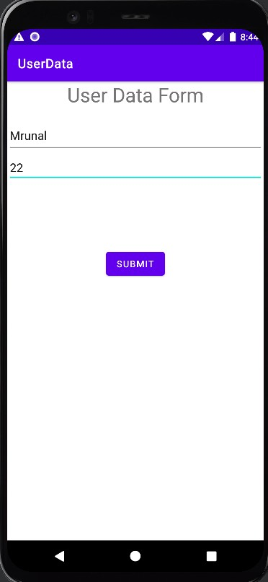

NAME : Ashutosh Rode ROLL NO : 72 DIV : B

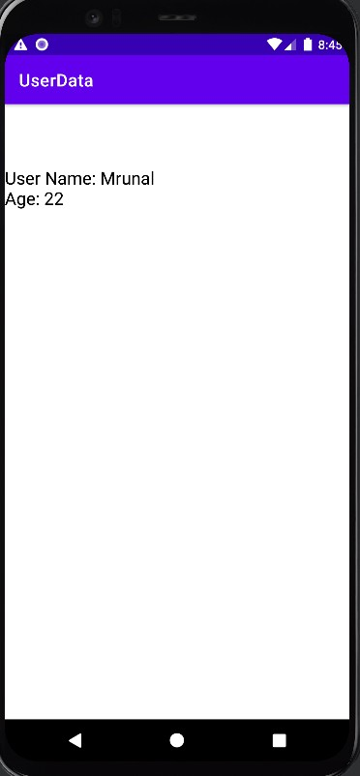

Q5]Create an android application to demonstrate the working of bundle class, where create first activity as student marksheet and display the content result on second activity and display congratulation on third activity or try again on third activity.Use bundle concept.

<?xml version="1.0" encoding="utf-8"?>

<LinearLayout xmlns:android="[http://schemas.android.com/apk/res/android"](http://schemas.android.com/apk/res/android) xmlns:app="<http://schemas.android.com/apk/res-auto>" xmlns:tools="<http://schemas.android.com/tools>" android:layout_width="match_parent" android:layout_height="match_parent" android:orientation="vertical"

android:padding="16dp" tools:context=".MainActivity">

<EditText android:id="@+id/markEditText1" android:layout_width="match_parent" android:layout_height="wrap_content" android:hint="Enter Mark 1" android:inputType="number" />

<EditText android:id="@+id/markEditText2" android:layout_width="match_parent" android:layout_height="wrap_content" android:hint="Enter Mark 2"

NAME : Ashutosh Rode ROLL NO : 72 DIV : B

android:inputType="number" />

<EditText android:id="@+id/markEditText3" android:layout_width="match_parent" android:layout_height="wrap_content" android:hint="Enter Mark 3" android:inputType="number" />

<Button

android:id="@+id/calculateButton" android:layout_width="wrap_content" android:layout_height="wrap_content" android:text="Calculate Result" />

</LinearLayout>

package com.example.studentmarksheet;

import androidx.appcompat.app.AppCompatActivity; import android.os.Bundle;

import android.content.Intent; import android.os.Bundle; import android.view.View; import android.widget.Button; import android.widget.EditText; import android.widget.Toast;

import androidx.appcompat.app.AppCompatActivity; public class MainActivity extends AppCompatActivity {

private EditText markEditText1, markEditText2, markEditText3; private Button calculateButton;

@Override

protected void onCreate(Bundle savedInstanceState) { super.onCreate(savedInstanceState); setContentView(R.layout.*activity_main*); markEditText1 = findViewById(R.id.*markEditText1*); markEditText2 = findViewById(R.id.*markEditText2*); markEditText3 = findViewById(R.id.*markEditText3*); calculateButton = findViewById(R.id.*calculateButton*);

calculateButton.setOnClickListener(new View.OnClickListener() { @Override

public void onClick(View v) {

int mark1 = Integer.*parseInt*(markEditText1.getText().toString()); int mark2 = Integer.*parseInt*(markEditText2.getText().toString()); int mark3 = Integer.*parseInt*(markEditText3.getText().toString()); int totalMarks = mark1 + mark2 + mark3;

int averageMarks = totalMarks / 3; String result;

NAME : Ashutosh Rode ROLL NO : 72 DIV : B

if (averageMarks >= 60) { result = "Pass";

} else {

result = "Fail";

}

});

}

}

}

Intent intent = new Intent(MainActivity.this, ResultActivity.class); intent.putExtra("RESULT", result);

startActivity(intent);

<?xml version="1.0" encoding="utf-8"?>

<LinearLayout xmlns:android="[http://schemas.android.com/apk/res/android"](http://schemas.android.com/apk/res/android) xmlns:app="<http://schemas.android.com/apk/res-auto>" xmlns:tools="<http://schemas.android.com/tools>" android:layout_width="match_parent" android:layout_height="match_parent" android:orientation="vertical"

android:padding="16dp" tools:context=".ResultActivity">

<TextView android:id="@+id/resultText" android:layout_width="wrap_content"

android:layout_height="wrap_content" android:text="Result will be displayed here" />

<Button

android:id="@+id/proceedButton" android:layout_width="wrap_content" android:layout_height="wrap_content" android:text="Proceed" />

</LinearLayout>

<?xml version="1.0" encoding="utf-8"?>

<LinearLayout xmlns:android="[http://schemas.android.com/apk/res/android"](http://schemas.android.com/apk/res/android) android:layout_width="match_parent" android:layout_height="match_parent" android:orientation="vertical"

android:padding="16dp">

<TextView android:id="@+id/finalMessage" android:layout_width="wrap_content" android:layout_height="wrap_content"

NAME : Ashutosh Rode ROLL NO : 72 DIV : B

android:text="Congratulations or Try Again message will be displayed here" />

</LinearLayout>

package com.example.studentmarksheet; import android.content.Intent;

import android.os.Bundle; import android.widget.TextView;

import androidx.appcompat.app.AppCompatActivity; public class FinalActivity extends AppCompatActivity {

private TextView finalMessage; @Override

protected void onCreate(Bundle savedInstanceState) { super.onCreate(savedInstanceState); setContentView(R.layout.*activity_final*); finalMessage = findViewById(R.id.*finalMessage*); Intent intent = getIntent();

String result = intent.getStringExtra("RESULT"); if (result != null) {

if (result.equals("Pass")) { finalMessage.setText("Congratulations!");

} else {

finalMessage.setText("Try Again.");

}

} else {

finalMessage.setText("Result is not available.");

}

}

}

NAME : Ashutosh Rode ROLL NO : 72 DIV : B

Q6] Create an android application to demonstrate working of simple adapter Activity_main.xml:

<?xml version="1.0" encoding="utf-8"?>

<LinearLayout xmlns:android="[http://schemas.android.com/apk/res/android"](http://schemas.android.com/apk/res/android) xmlns:app="<http://schemas.android.com/apk/res-auto>" xmlns:tools="<http://schemas.android.com/tools>" android:layout_width="match_parent" android:layout_height="match_parent" android:orientation="vertical"

android:padding="16dp" tools:context=".MainActivity">

<TextView android:layout_width="wrap_content" android:layout_height="wrap_content" android:text="List View With Simple Array" android:backgroundTint="@color/teal_700" android:background="@color/teal_700" android:textSize="20dp"/>

<ListView android:id="@+id/listView"

android:layout_width="match_parent" android:layout_height="wrap_content"/>

</LinearLayout> Mainactivity.java:

package com.example.listview; import android.os.Bundle;

import android.widget.ArrayAdapter; import android.widget.ListView;

import androidx.appcompat.app.AppCompatActivity; public class MainActivity extends AppCompatActivity {

@Override

protected void onCreate(Bundle savedInstanceState) { super.onCreate(savedInstanceState); setContentView(R.layout.*activity_main*);

String[] items = {"DSA", "JAVA", "Android", "C++", "Python"}; ArrayAdapter<String> adapter = new ArrayAdapter<>(this,

android.R.layout.*simple_list_item_1*, items);

ListView listView = findViewById(R.id.*listView*); listView.setAdapter(adapter);

}

}

Output:

NAME : Ashutosh Rode ROLL NO : 72 DIV : B

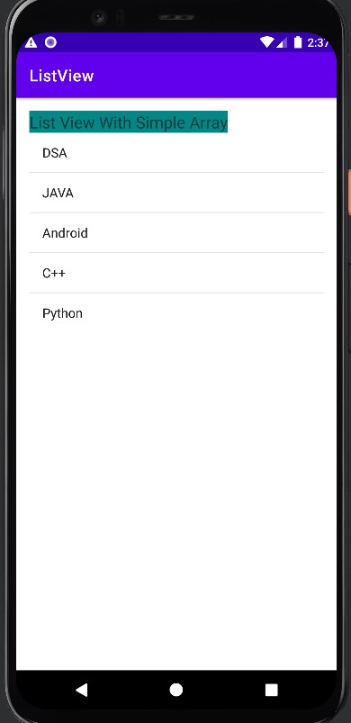

Q7] Create an android application to demonstrate the working of custom adapter use string.xml resource file.

Activity_main.xml:

<?xml version="1.0" encoding="utf-8"?>

<LinearLayout xmlns:android="[http://schemas.android.com/apk/res/android"](http://schemas.android.com/apk/res/android) xmlns:app="<http://schemas.android.com/apk/res-auto>" xmlns:tools="<http://schemas.android.com/tools>" android:layout_width="match_parent" android:layout_height="match_parent"

android:orientation="vertical" android:padding="16dp" tools:context=".MainActivity">

<EditText android:id="@+id/nameEditText" android:layout_width="match_parent" android:layout_height="wrap_content" android:hint="Enter your name" />

<Spinner android:id="@+id/pizzaTypeSpinner" android:layout_width="match_parent" android:layout_height="wrap_content" android:layout_marginTop="16dp" android:entries="@array/pizza_types" />

NAME : Ashutosh Rode ROLL NO : 72 DIV : B

<Button

android:id="@+id/submitButton" android:layout_width="match_parent" android:layout_height="wrap_content" android:text="Submit" />

</LinearLayout> Mainactivity.java:

package com.example.pizzaordering; import android.content.Intent; import android.os.Bundle;

import android.view.View;

import android.widget.AdapterView; import android.widget.ArrayAdapter; import android.widget.Button; import android.widget.EditText; import android.widget.Spinner;

import androidx.appcompat.app.AppCompatActivity; import com.example.pizzaordering.OrderSummaryActivity; import com.example.pizzaordering.R;

public class MainActivity extends AppCompatActivity { private EditText nameEditText;

private Spinner pizzaTypeSpinner; @Override

protected void onCreate(Bundle savedInstanceState) { super.onCreate(savedInstanceState); setContentView(R.layout.*activity_main*); nameEditText = findViewById(R.id.*nameEditText*);

pizzaTypeSpinner = findViewById(R.id.*pizzaTypeSpinner*); ArrayAdapter<CharSequence> adapter = ArrayAdapter.*createFromResource*(

this, R.array.*pizza_types*,

android.R.layout.*simple_spinner_item*

);

adapter.setDropDownViewResource(android.R.layout.*simple_spinner_dropdown_item*); pizzaTypeSpinner.setAdapter(adapter);

pizzaTypeSpinner.setPrompt("Select pizza type");

Button submitButton = findViewById(R.id.*submitButton*); submitButton.setOnClickListener(new View.OnClickListener() {

@Override

public void onClick(View view) {

String name = nameEditText.getText().toString();

String pizzaType = pizzaTypeSpinner.getSelectedItem().toString();

Intent intent = new Intent(MainActivity.this, OrderSummaryActivity.class); intent.putExtra("name", name);

intent.putExtra("pizzaType", pizzaType);

NAME : Ashutosh Rode ROLL NO : 72 DIV : B

startActivity(intent);

}

});

}

}

arrays.xml:

<resources>

<string-array name="pizza_types">

<item>Cheese Pizza</item>

<item>Pepperoni Pizza</item>

<item>Veggie Pizza</item>

<!-- Add more pizza types as needed -->

</string-array>

</resources> Output:

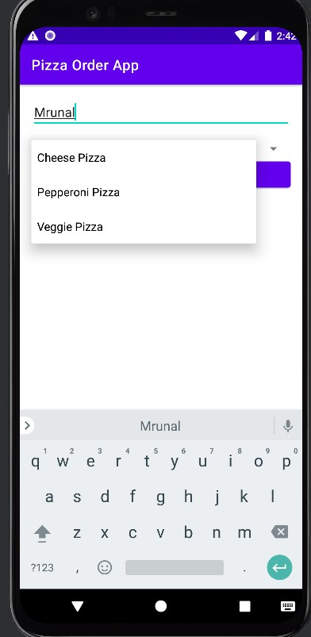

NAME : Ashutosh Rode ROLL NO : 72 DIV : B

Q8] Create an android application to implement Alert dialog box , where create a quiz of atleast 5 MCQ and display the result on alert box and after click on positive button of alert Box display toast successful.

Activity_main.xml:

<LinearLayout xmlns:android="[http://schemas.android.com/apk/res/android"](http://schemas.android.com/apk/res/android) android:layout_width="match_parent" android:layout_height="match_parent" android:orientation="vertical">

<!-- Question 1 -->

<TextView android:layout_width="wrap_content" android:layout_height="wrap_content"

android:text="Question 1: What is the capital of France?" />

<RadioGroup android:id="@+id/radio_group_question1" android:layout_width="match_parent" android:layout_height="wrap_content">

<RadioButton android:id="@+id/option1_question1" android:layout_width="wrap_content" android:layout_height="wrap_content" android:text="Paris" />

<RadioButton android:id="@+id/option2_question1" android:layout_width="wrap_content" android:layout_height="wrap_content" android:text="London" />

</RadioGroup>

<!-- Question 2 -->

<TextView android:layout_width="wrap_content" android:layout_height="wrap_content"

android:text="Question 2: What is the largest planet in our solar system?" />

<RadioGroup android:id="@+id/radio_group_question2" android:layout_width="match_parent" android:layout_height="wrap_content">

<RadioButton android:id="@+id/option1_question2" android:layout_width="wrap_content" android:layout_height="wrap_content" android:text="Mars" />

<RadioButton

NAME : Ashutosh Rode ROLL NO : 72 DIV : B

android:id="@+id/option2_question2" android:layout_width="wrap_content" android:layout_height="wrap_content" android:text="Jupiter" />

</RadioGroup>

<TextView android:layout_width="wrap_content" android:layout_height="wrap_content"

android:text="Question 3: Which is the java framework?" />

<RadioGroup android:id="@+id/radio_group_question3" android:layout_width="match_parent" android:layout_height="wrap_content">

<RadioButton android:id="@+id/option1_question3" android:layout_width="wrap_content" android:layout_height="wrap_content" android:text="Django" />

<RadioButton android:id="@+id/option2_question3" android:layout_width="wrap_content" android:layout_height="wrap_content" android:text="Springboot" />

</RadioGroup>

<TextView android:layout_width="wrap_content" android:layout_height="wrap_content"

android:text="Question 4: Which is the python framework?" />

<RadioGroup android:id="@+id/radio_group_question4" android:layout_width="match_parent" android:layout_height="wrap_content">

<RadioButton android:id="@+id/option1_question4" android:layout_width="wrap_content" android:layout_height="wrap_content" android:text="Django" />

<RadioButton android:id="@+id/option2_question4" android:layout_width="wrap_content" android:layout_height="wrap_content" android:text="Springboot" />

</RadioGroup>

<TextView android:layout_width="wrap_content" android:layout_height="wrap_content"

NAME : Ashutosh Rode ROLL NO : 72 DIV : B

android:text="Question 5: Which is the object oriented language" />

<RadioGroup android:id="@+id/radio_group_question5" android:layout_width="match_parent" android:layout_height="wrap_content">

<RadioButton android:id="@+id/option1_question5" android:layout_width="wrap_content" android:layout_height="wrap_content" android:text="Java" />

<RadioButton android:id="@+id/option2_question5" android:layout_width="wrap_content" android:layout_height="wrap_content" android:text="C" />

</RadioGroup>

<Button

android:id="@+id/submit_button" android:layout_width="wrap_content" android:layout_height="wrap_content" android:text="Submit Quiz" />

</LinearLayout> Mainactivity.java:

package com.example.quizz; import android.app.AlertDialog;

import android.content.DialogInterface; import android.os.Bundle;

import android.view.View; import android.widget.Button;

import android.widget.RadioGroup; import android.widget.Toast;

import androidx.appcompat.app.AppCompatActivity; public class MainActivity extends AppCompatActivity {

private int score = 0;

private RadioGroup question1RadioGroup; private RadioGroup question2RadioGroup; private RadioGroup question3RadioGroup; @Override

protected void onCreate(Bundle savedInstanceState) { super.onCreate(savedInstanceState); setContentView(R.layout.*activity_main*);

question1RadioGroup = findViewById(R.id.*radio_group_question1*); question2RadioGroup = findViewById(R.id.*radio_group_question2*); question3RadioGroup = findViewById(R.id.*radio_group_question3*); Button submitButton = findViewById(R.id.*submit_button*);

NAME : Ashutosh Rode ROLL NO : 72 DIV : B

submitButton.setOnClickListener(new View.OnClickListener() { @Override

public void onClick(View view) { calculateScore(); showScoreDialog(score);

}

});

}

private void calculateScore() {

// Question 1: Check the selected answer and update the score

int selectedAnswer1 = question1RadioGroup.getCheckedRadioButtonId(); if (selectedAnswer1 == R.id.*option1_question1*) {

score++;

}

// Question 2: Check the selected answer and update the score

int selectedAnswer2 = question2RadioGroup.getCheckedRadioButtonId(); if (selectedAnswer2 == R.id.*option2_question2*) {

score++;

}

int selectedAnswer3 = question3RadioGroup.getCheckedRadioButtonId(); if (selectedAnswer3 == R.id.*option2_question3*) {

score++;

}

int selectedAnswer4 = question3RadioGroup.getCheckedRadioButtonId(); if (selectedAnswer4 == R.id.*option2_question3*) {

score++;

}

int selectedAnswer5 = question3RadioGroup.getCheckedRadioButtonId(); if (selectedAnswer5 == R.id.*option2_question3*) {

score++;

}

}

private void showScoreDialog(int score) {

AlertDialog.Builder builder = new AlertDialog.Builder(this); builder.setTitle("Quiz Results");

builder.setMessage("Your score: " + score); builder.setPositiveButton("OK", new DialogInterface.OnClickListener() {

@Override

public void onClick(DialogInterface dialog, int which) { dialog.dismiss();

// Display a thank you message when the dialog is dismissed Toast.*makeText*(getApplicationContext(), "Thank you!",

Toast.*LENGTH_SHORT*).show();

NAME : Ashutosh Rode ROLL NO : 72 DIV : B

}

});

AlertDialog dialog = builder.create(); dialog.show();

}

}

Output:

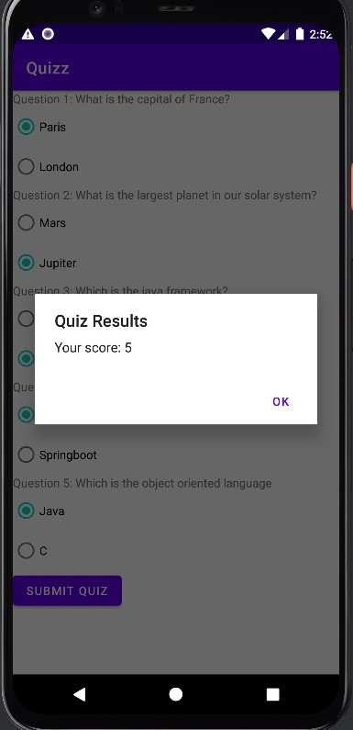

Q9] Create an android application to implement Date Picker dialog box Activity_main.xml:

<?xml version="1.0" encoding="utf-8"?>

<LinearLayout xmlns:android="[http://schemas.android.com/apk/res/android"](http://schemas.android.com/apk/res/android) xmlns:app="<http://schemas.android.com/apk/res-auto>" xmlns:tools="<http://schemas.android.com/tools>" android:layout_width="match_parent" android:layout_height="match_parent"

NAME : Ashutosh Rode ROLL NO : 72 DIV : B

android:orientation="vertical" android:padding="16dp" tools:context=".MainActivity">

<EditText android:id="@+id/dateEditText" android:layout_width="match_parent" android:layout_height="wrap_content" android:hint="Select Date" android:focusable="false" android:clickable="true" android:inputType="none" />

<Button

android:layout_width="wrap_content" android:layout_height="wrap_content" android:text="Pick Date" android:id="@+id/pickDateButton" />

</LinearLayout> Mainactivity.java:

package com.example.datepickerdialog;

import androidx.appcompat.app.AppCompatActivity; import android.app.DatePickerDialog;

import android.os.Bundle; import android.view.View; import android.widget.Button;

import android.widget.DatePicker; import android.widget.EditText; import java.util.Calendar;

public class MainActivity extends AppCompatActivity { private EditText dateEditText;

private Button pickDateButton; private Calendar calendar; private int year, month, day; @Override

protected void onCreate(Bundle savedInstanceState) { super.onCreate(savedInstanceState); setContentView(R.layout.*activity_main*); dateEditText = findViewById(R.id.*dateEditText*);

pickDateButton = findViewById(R.id.*pickDateButton*); calendar = Calendar.*getInstance*();

year = calendar.get(Calendar.*YEAR*); month = calendar.get(Calendar.*MONTH*);

day = calendar.get(Calendar.*DAY_OF_MONTH*); pickDateButton.setOnClickListener(new View.OnClickListener() {

NAME : Ashutosh Rode ROLL NO : 72 DIV : B

@Override

public void onClick(View v) { showDatePickerDialog();

}

});

}

private void showDatePickerDialog() {

DatePickerDialog datePickerDialog = new DatePickerDialog(this, new DatePickerDialog.OnDateSetListener() {

@Override

public void onDateSet(DatePicker view, int selectedYear, int selectedMonth, int selectedDay) {

year = selectedYear; month = selectedMonth; day = selectedDay;

dateEditText.setText(year + "-" + (month + 1) + "-" + day);

}

}, year, month, day); datePickerDialog.show();

}

}

Output:

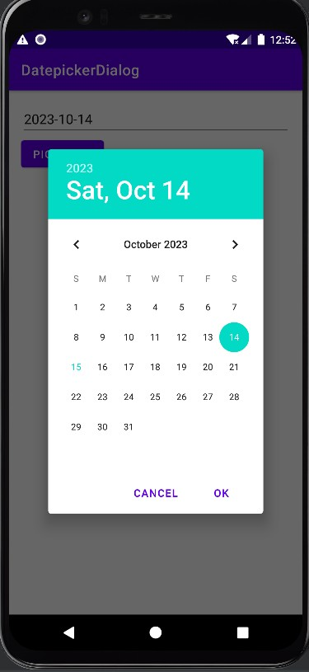

NAME : Ashutosh Rode ROLL NO : 72 DIV : B

Q10] Create an android application to implement Date Picker using Calendar class.

<LinearLayout xmlns:android="[http://schemas.android.com/apk/res/android"](http://schemas.android.com/apk/res/android) xmlns:app="<http://schemas.android.com/apk/res-auto>" xmlns:tools="<http://schemas.android.com/tools>" android:layout_width="match_parent" android:layout_height="match_parent" android:orientation="vertical"

android:padding="16dp" tools:context=".MainActivity">

<Button

android:id="@+id/pickDateButton" android:layout_width="wrap_content" android:layout_height="wrap_content" android:text="Pick a Date" />

<TextView android:id="@+id/displayDateText" android:layout_width="wrap_content" android:layout_height="wrap_content" android:layout_marginTop="16dp" android:text="" />

</LinearLayout> Mainactivity.java:

package com.example.datepickercalendar;

import androidx.appcompat.app.AppCompatActivity; import android.app.DatePickerDialog;

import android.os.Bundle; import android.view.View; import android.widget.Button;

import android.widget.DatePicker; import android.widget.TextView;

import java.text.SimpleDateFormat; import java.util.Calendar;

import java.util.Locale;

public class MainActivity extends AppCompatActivity { private Button pickDateButton;

NAME : Ashutosh Rode ROLL NO : 72 DIV : B

private TextView displayDateText; private Calendar calendar;

@Override

protected void onCreate(Bundle savedInstanceState) { super.onCreate(savedInstanceState); setContentView(R.layout.*activity_main*);

pickDateButton = findViewById(R.id.*pickDateButton*); displayDateText = findViewById(R.id.*displayDateText*); calendar = Calendar.*getInstance*();

pickDateButton.setOnClickListener(new View.OnClickListener() { @Override

public void onClick(View v) {

int year = calendar.get(Calendar.*YEAR*);

int month = calendar.get(Calendar.*MONTH*);

int day = calendar.get(Calendar.*DAY_OF_MONTH*);

// Create a DatePickerDialog to pick a date

DatePickerDialog datePickerDialog = new DatePickerDialog( MainActivity.this,

new DatePickerDialog.OnDateSetListener() { @Override

public void onDateSet(DatePicker view, int year, int month, int

dayOfMonth) {

}

},

calendar.set(Calendar.*YEAR*, year); calendar.set(Calendar.*MONTH*, month); calendar.set(Calendar.*DAY_OF_MONTH*, dayOfMonth); updateDisplayDate();

year, month, day

);

datePickerDialog.show();

}

});

}

private void updateDisplayDate() {

SimpleDateFormat sdf = new SimpleDateFormat("dd/MM/yyyy", Locale.*US*); String formattedDate = sdf.format(calendar.getTime()); displayDateText.setText("Selected Date: " + formattedDate);

}

}

NAME : Ashutosh Rode ROLL NO : 72 DIV : B

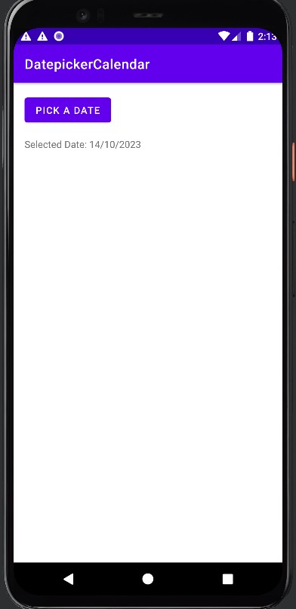

Q11] Create an android application to implement Time picker.

<?xml version="1.0" encoding="utf-8"?>

<LinearLayout xmlns:android="[http://schemas.android.com/apk/res/android"](http://schemas.android.com/apk/res/android) xmlns:app="<http://schemas.android.com/apk/res-auto>" xmlns:tools="<http://schemas.android.com/tools>" android:layout_width="match_parent" android:layout_height="match_parent" android:orientation="vertical"

android:padding="16dp" tools:context=".MainActivity">

<Button

android:id="@+id/pickTimeButton" android:layout_width="wrap_content" android:layout_height="wrap_content" android:text="Pick a Time" />

<TextView android:id="@+id/displayTimeText"

NAME : Ashutosh Rode ROLL NO : 72 DIV : B

android:layout_width="wrap_content" android:layout_height="wrap_content" android:layout_marginTop="16dp" android:text="" />

</LinearLayout> Mainactivity.java:

package com.example.timepicker;

import androidx.appcompat.app.AppCompatActivity; import android.app.TimePickerDialog;

import android.os.Bundle; import android.view.View; import android.widget.Button; import android.widget.TextView;

import android.widget.TimePicker;

import java.text.SimpleDateFormat; import java.util.Calendar;

import java.util.Locale;

public class MainActivity extends AppCompatActivity { private Button pickTimeButton;

private TextView displayTimeText; private Calendar calendar;

@Override

protected void onCreate(Bundle savedInstanceState) { super.onCreate(savedInstanceState); setContentView(R.layout.*activity_main*);

pickTimeButton = findViewById(R.id.*pickTimeButton*); displayTimeText = findViewById(R.id.*displayTimeText*); calendar = Calendar.*getInstance*();

pickTimeButton.setOnClickListener(new View.OnClickListener() { @Override

public void onClick(View v) {

int hour = calendar.get(Calendar.*HOUR_OF_DAY*); int minute = calendar.get(Calendar.*MINUTE*);

// Create a TimePickerDialog to pick a time

TimePickerDialog timePickerDialog = new TimePickerDialog( MainActivity.this,

NAME : Ashutosh Rode ROLL NO : 72 DIV : B

new TimePickerDialog.OnTimeSetListener() { @Override

public void onTimeSet(TimePicker view, int hourOfDay, int minute) { calendar.set(Calendar.*HOUR_OF_DAY*, hourOfDay); calendar.set(Calendar.*MINUTE*, minute);

updateDisplayTime();

}

},

hour, minute, false

);

timePickerDialog.show();

}

});

}

private void updateDisplayTime() {

SimpleDateFormat sdf = new SimpleDateFormat("hh:mm a", Locale.*US*); String formattedTime = sdf.format(calendar.getTime()); displayTimeText.setText("Selected Time: " + formattedTime);

}

}

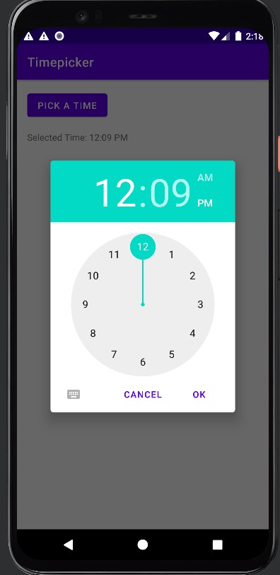

NAME : Ashutosh Rode ROLL NO : 72 DIV : B

Q12] Create an android application to demonstrate working of Option Menu for famous countries.

package com.example.menubar;

import androidx.annotation.NonNull;

import androidx.appcompat.app.AppCompatActivity;

import android.os.Bundle; import android.view.Menu; import android.view.MenuItem; import android.widget.Toast;

public class OptionMenuBar extends AppCompatActivity { @Override

protected void onCreate(Bundle savedInstanceState) {

super.onCreate(savedInstanceState); setContentView(R.layout.*activity_option_menu_bar*);

}

@Override

public boolean onCreateOptionsMenu(Menu menu) { getMenuInflater().inflate(R.menu.*option_menubar*,menu);

return true;

}

@Override

public boolean onOptionsItemSelected(@NonNull MenuItem item) { int item_id= item.getItemId();

switch(item_id){ case R.id.*india*:

Toast.*makeText*(this,"India is selected",Toast.*LENGTH_SHORT*).show(); return true;

case R.id.*brazil*:

Toast.*makeText*(this,"Brazil is selected",Toast.*LENGTH_SHORT*).show(); return true;

case R.id.*france*:

Toast.*makeText*(this,"France is selected",Toast.*LENGTH_SHORT*).show(); return true;

NAME : Ashutosh Rode ROLL NO : 72 DIV : B

default:

return super.onOptionsItemSelected(item);

}

}

}

option_menu.xml:

<?xml version="1.0" encoding="utf-8"?>

<menu xmlns:android="[http://schemas.android.com/apk/res/android"](http://schemas.android.com/apk/res/android)>

<item

android:title="India" android:id="@+id/india"

/>

<item

android:title="Brazil" android:id="@+id/brazil"

/>

<item

android:title="France" android:id="@+id/france"

/>

</menu>

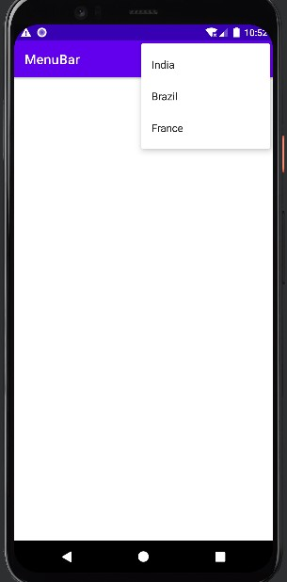

NAME : Ashutosh Rode ROLL NO : 72 DIV : B

Q13] Create an android application to demonstrate working of popup menu for menu of food

<?xml version="1.0" encoding="utf-8"?>

<LinearLayout xmlns:android="[http://schemas.android.com/apk/res/android"](http://schemas.android.com/apk/res/android) xmlns:app="<http://schemas.android.com/apk/res-auto>" xmlns:tools="<http://schemas.android.com/tools>" android:layout_width="match_parent" android:layout_height="match_parent"

tools:context=".PopupMenuBar"

>

<Button

android:layout_width="wrap_content" android:layout_height="wrap_content" android:id="@+id/btn1" android:text="Food Type" android:layout_marginTop="200dp" android:layout_marginLeft="150dp"/>

</LinearLayout>

package com.example.menubar;

import androidx.appcompat.app.AppCompatActivity; import android.widget.Button;

import android.widget.PopupMenu; import android.widget.Toast;

public class PopupMenuBar extends AppCompatActivity { Button btn1;

@Override

protected void onCreate(Bundle savedInstanceState) { super.onCreate(savedInstanceState); setContentView(R.layout.*activity_popup_menu_bar*); btn1=findViewById(R.id.*btn1*); btn1.setOnClickListener(new View.OnClickListener() {

@Override

public void onClick(View view) {

PopupMenu popupMenu=new PopupMenu(PopupMenuBar.this,btn1);

popupMenu.getMenuInflater().inflate(R.menu.*popup_menu*,popupMenu.getMenu()); popupMenu.setOnMenuItemClickListener(new

PopupMenu.OnMenuItemClickListener() { @Override

public boolean onMenuItemClick(MenuItem menuItem) {

Toast.*makeText*(PopupMenuBar.this,menuItem.getTitle(),Toast.*LENGTH_SHORT*).show(); return true;

NAME : Ashutosh Rode ROLL NO : 72 DIV : B

}

});

popupMenu.show();

}

});

}

}

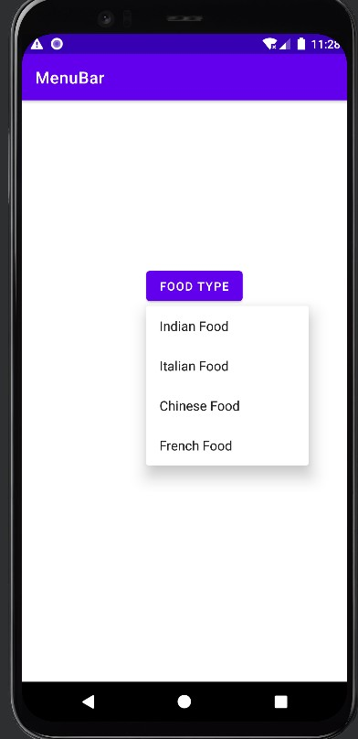

Q14]Create an android application to demonstrate working of Context Menu for all file options<?xml version="1.0" encoding="utf-8"?>

<LinearLayout xmlns:android="[http://schemas.android.com/apk/res/android"](http://schemas.android.com/apk/res/android) xmlns:app="<http://schemas.android.com/apk/res-auto>" xmlns:tools="<http://schemas.android.com/tools>" android:layout_width="match_parent" android:layout_height="match_parent" tools:context=".ContextMenuBar">

<ListView android:layout_width="match_parent" android:layout_height="match_parent" android:id="@+id/fileslist"

/>

</LinearLayout>

NAME : Ashutosh Rode ROLL NO : 72 DIV : B

package com.example.menubar;

import androidx.appcompat.app.AppCompatActivity; import android.os.Bundle;

import android.view.ContextMenu; import android.view.View;

import android.widget.ArrayAdapter; import android.widget.ListView;

public class ContextMenuBar extends AppCompatActivity { ListView file_list;

String[] files={"PDF","DOCS","HTML","PPT","ZIP"};

@Override

protected void onCreate(Bundle savedInstanceState) { super.onCreate(savedInstanceState); setContentView(R.layout.*activity_context_menu_bar*); file_list=(ListView) findViewById(R.id.*fileslist*); ArrayAdapter<String> adapter=new ArrayAdapter<>(this,

android.R.layout.*simple_list_item_1*,files); file_list.setAdapter(adapter); registerForContextMenu(file_list);

}

@Override

public void onCreateContextMenu(ContextMenu menu, View v, ContextMenu.ContextMenuInfo menuInfo) {

super.onCreateContextMenu(menu, v, menuInfo); getMenuInflater().inflate(R.menu.*context_menu*,menu);

}

}

NAME : Ashutosh Rode ROLL NO : 72 DIV : B

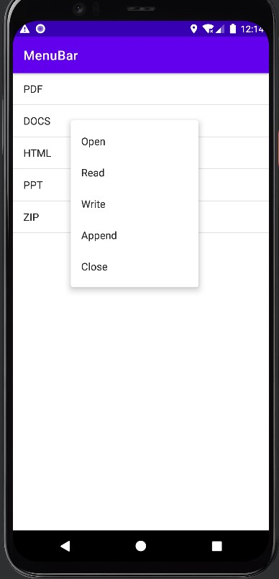

Q15] Create an android application to implement rating bar.

<?xml version="1.0" encoding="utf-8"?>

<RelativeLayout xmlns:android="[http://schemas.android.com/apk/res/android"](http://schemas.android.com/apk/res/android) xmlns:app="<http://schemas.android.com/apk/res-auto>" xmlns:tools="<http://schemas.android.com/tools>" android:layout_width="match_parent" android:layout_height="match_parent"

tools:context=".MainActivity">

<TextView android:id="@+id/txt1"

android:layout_width="match_parent" android:layout_height="wrap_content" android:text="Rating Bar Example" android:textSize="30dp" android:textAlignment="center" android:paddingBottom="30dp"/>

<RatingBar android:id="@+id/rating"

android:layout_width="wrap_content" android:layout_height="wrap_content" android:layout_below="@+id/txt1" android:layout_centerHorizontal="true"

NAME : Ashutosh Rode ROLL NO : 72 DIV : B

android:layout_marginTop="50dp"

/>

<Button

android:layout_width="wrap_content" android:layout_height="wrap_content" android:id="@+id/btn1" android:text="Submit" android:layout_below="@+id/rating" android:layout_centerHorizontal="true" android:layout_marginTop="40dp"/>

</RelativeLayout>

import androidx.appcompat.app.AppCompatActivity; import android.os.Bundle;

import android.view.View; import android.widget.Button; import android.widget.RatingBar; import android.widget.Toast;

public class MainActivity extends AppCompatActivity { RatingBar rating;

Button btn1; @Override

protected void onCreate(Bundle savedInstanceState) { super.onCreate(savedInstanceState); setContentView(R.layout.*activity_main*); rating=findViewById(R.id.*rating*); btn1=findViewById(R.id.*btn1*); btn1.setOnClickListener(new View.OnClickListener() {

@Override

public void onClick(View view) {

String star= String.*valueOf*(rating.getRating());

Toast.*makeText*(getApplicationContext(),star+"Rating",Toast.*LENGTH_SHORT*).show();

}

});

}

}

NAME : Ashutosh Rode ROLL NO : 72 DIV : B

